Ryan Farruggia

CSC 35

Professor Ghansah

6 April 2021

Lab Report #9

Screenshot of output using (1,1), (1,999), (40000, 16), and ‘q’ to quit the program:

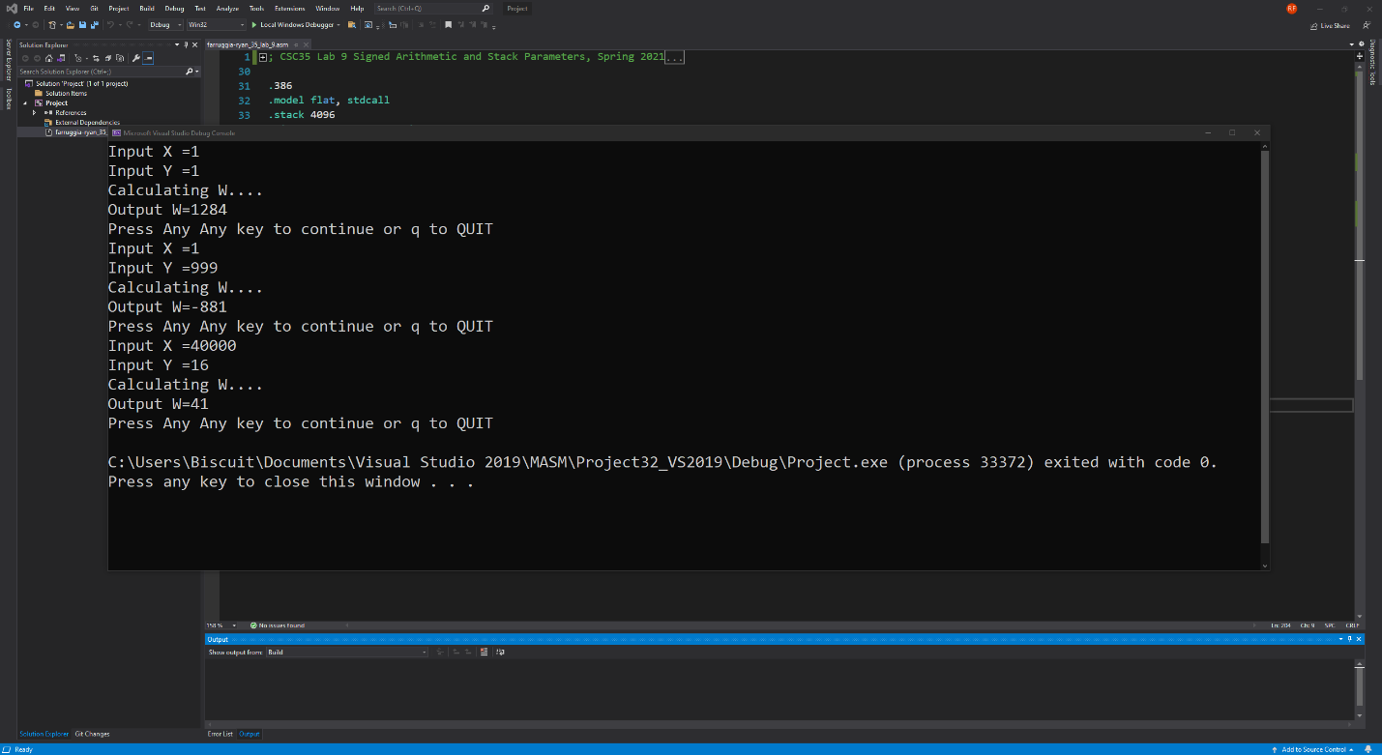

Screenshot of getinput procedure:

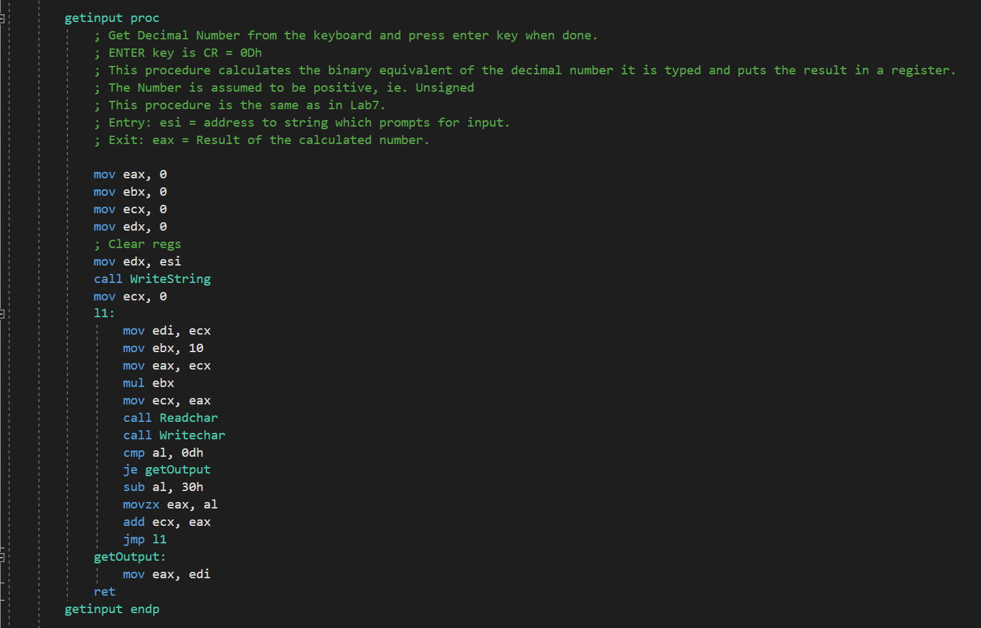

Screenshot of CalculateW procedure:

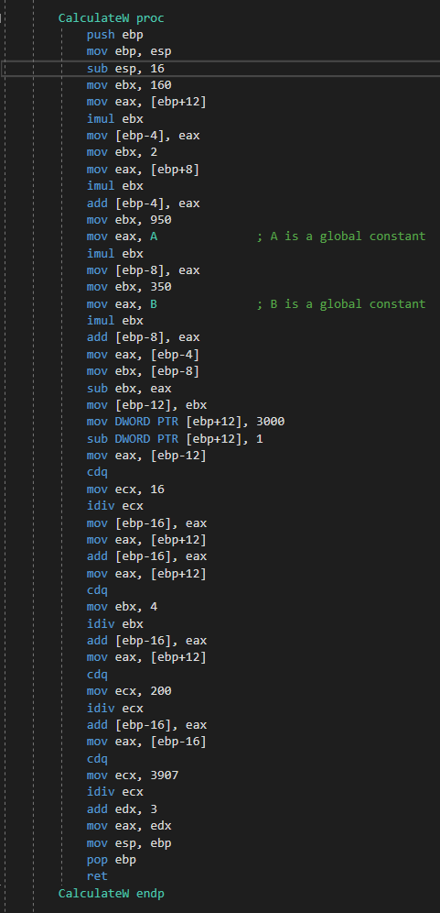

Screenshot of outW procedure:

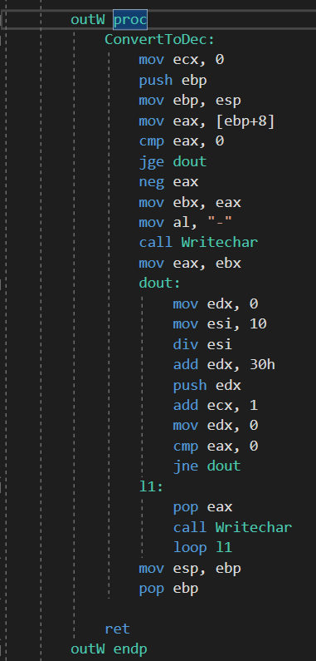

**Length:** This lab took about one day to complete.

**Problems:** It took a while to figure out which ‘loc’ variables to replace with memory addresses and it was especially difficult to refactor my CalculateW procedure to allow for these changes in addresses. I need to add on pointers to some pieces to prevent overflows/errors.

**Lessons Learned:** To reallocate local variables from Lab 7, it’s integral to use memory addresses depending on how many bytes you expect to use during operation. Also in some cases a pointer may be necessary for the operation to properly function.

**Suggestions:** Make the comments on the source file a little more concise and make the requirements consistent with the word document provided with the .asm file. I was confused because the requirements on the document differed from the comments prepared on the assembly file provided on canvas which makes it a bit impossible to know what is expected from my end.